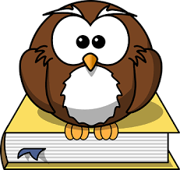
Oxford Owl reading books for each group
Week beginning 25th January

- Grey group – The Ice and Snow book
- Yellow group – A hungry fox
- Orange group - Horses
- Pink group – Dragon boy
- Red group – Sun hat fun

