Relationships and Sex Education policy
(2022)
Including Relationships Education and Physical Health and Mental Wellbeing

Hollins Grundy Primary School

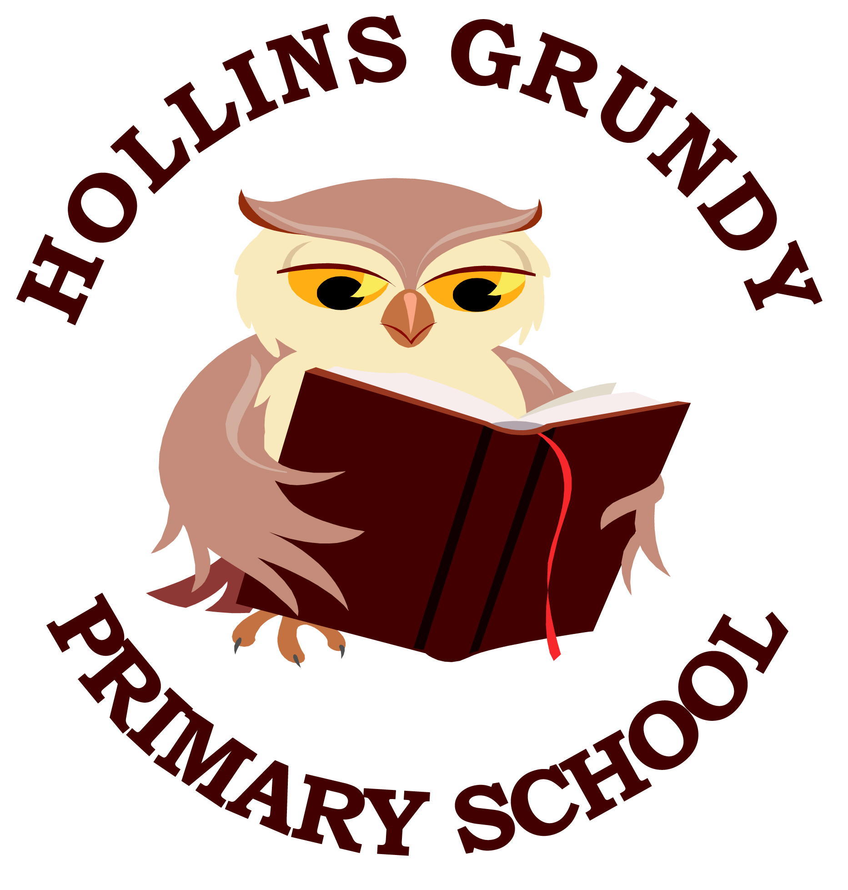

Approved by: | Governing Body | Date: 04.10.2022
Last reviewed on: | 03.10.2022
Next review due by: | 31.10.2023

Contents
1. Aims 3
2. Statutory requirements 3
3. Policy development 3
4. Definition 3
5. Curriculum 4
6. Delivery of RSE 4
7. Roles and responsibilities 5
8. Parents’ right to withdraw 6
9. Training 6
10. Monitoring arrangements 6
Appendix 1: Curriculum map 7
Appendix 2: By the end of primary school pupils should know 7
Appendix 3: Parent form: withdrawal from sex education within RSE 15

1. Aims
The teaching of Relationships Education, Physical Health and Mental Wellbeing and Relationships and Sex Education very much support our school’s ethos and values as described by our mission statement: Happiness, Health and Respect for Confident, Creative Learners.
The aims of relationships and sex education (RSE) at our school are to:
- Help pupils develop feelings of self-respect, confidence and empathy
- Prepare pupils for puberty, and give them an understanding of sexual development and the importance of health and hygiene
- Teach pupils the correct vocabulary to describe themselves and their bodies. This is an important safeguarding skill.
- Provide a framework in which sensitive discussions can take place

2. Statutory requirements
As a maintained primary school we must provide relationships education to all pupils as per section 34 of the Children and Social work act 2017.
However, we are not required to provide sex education but we do need to teach the elements of sex education contained in the science curriculum.
In teaching RSE, we must have regard to guidance issued by the secretary of state as outlined in section 403 of the Education Act 1996.
At Hollins Grundy Primary School we teach RSE as set out in this policy.

3. Policy development
This policy has been developed in consultation with staff, pupils and parents. The consultation and policy development process involved the following steps:
- Review - A working group pulled together all relevant information including relevant national and local guidance

- Staff consultation – all school staff were given the opportunity to look at the policy and make recommendations

- Parent/stakeholder consultation – parents and any interested parties were invited to attend a meeting about the policy

- Pupil consultation – we investigated what exactly pupils want from their RSE

- Ratification – once amendments were made, the policy was shared with governors and ratified

4. Definition
The content of Relationships Education is statutory and is defined in Appendix 1 as is the content of Physical Health and Mental Wellbeing. The content of Relationships and Sex Education goes beyond that of the above curricula and is decided by the school.
RSE involves a combination of sharing information, and exploring issues and values.
RSE is not about the promotion of sexual activity.

5. Curriculum
Our curriculum is set out as per Appendices 2 and 3 but we may need to adapt it as and when necessary.
We have developed the curriculum in consultation with parents, pupils and staff, taking into account the age, needs and feelings of pupils. If pupils ask questions outside the scope of this policy, teachers will respond in an appropriate manner so they are fully informed and don’t seek answers online.
Primary sex education will focus on:
- How a baby is conceived and born
- That pregnancy can be achieved through IVF
- That pregnancy can be prevented by contraception
For more information about our curriculum, see our curriculum maps in Appendices 2 and 3.

6. Delivery of RSE
RSE is taught within the personal, social, health and economic (PSHE) education curriculum. Some biological aspects of RSE are taught within the science curriculum, some aspects of physical health are taught within the PE curriculum.
We choose to teach the Scheme of Work developed and supported by the PSHE Association (see Appendix 1) who are experts in this area. Children will be taught an annual programme delivered by their class teacher and supported by non-teaching staff. Additionally, outside speakers such as school nurses will be invited to contribute to the teaching where this can support and enhance the curriculum.
Children with SEND have a right to experience the same curriculum as other children. Some children with SEND can be more vulnerable than their peers therefore there is a greater imperative to teach the full curriculum to ensure their safety. Taking into account their developmental and academic needs, children with SEND will experience content appropriate for their year group.
Relationships education focuses on teaching the fundamental building blocks and characteristics of positive relationships including:
- Families and people who care for me
- Caring friendships
- Respectful relationships
- Online relationships
- Being safe
Physical Health and Mental Wellbeing focuses on teaching way in which children can learn to become healthy and resilient including:
- Mental wellbeing
- Internet safety and harms
- Physical health and fitness
- Healthy eating
- Drugs and alcohol
- Health and prevention
- Basic first aid
- Changing adolescent

The content of all three curricula (Relationships, Relationships and Sex, and Health and Wellbeing) will be taught to both boys and girls. In some circumstances, particularly when the subject is menstruation, it may be taught to them in separate groups.
For more information about our RSE curriculum, see Appendices 2 and 3.
These areas of learning are taught within the context of family life taking care to ensure that there is no stigmatisation of children based on their home circumstances (families can include single parent families, LGBT parents, families headed by grandparents, adoptive parents, foster parents/carers amongst other structures) along with reflecting sensitively that some children may have a different structure of support around them (for example: looked after children or young carers).

7. Roles and responsibilities
7.1 The governing board
The governing board will approve the RSE policy, and hold the headteacher to account for its implementation.
7.2 The headteacher
The headteacher is responsible for ensuring that RSE is taught consistently across the school, and for managing requests to withdraw pupils from non-statutory components of RSE (see section 8).
7.3 Staff
Staff are responsible for:
- Delivering RSE in a sensitive way
- Modelling positive attitudes to RSE
- Monitoring progress
- Responding to the needs of individual pupils
- Responding appropriately to pupils whose parents wish them to be withdrawn from the non-statutory components of RSE
Staff do not have the right to opt out of teaching RSE. Staff who have concerns about teaching RSE are encouraged to discuss this with the headteacher.
Staff roles within RSE are as follows:
Leadership | Teaching | Teaching Support
Simon Waddington  Vicky Gresty | Rachel Rhodes  Rachel Ellison  Connor McKenzie  Hayley Spencer  Andrea McCrory  Demi Allen  Paul McCrudden  Becky Jacques  Vicky Gresty | Wendy Abbotts  Maureen Sellars  Emma Litherland  Karen Mercer-Brown  Tubba Sajjid  Nicole Coombes  Clair Dunphy  Leanne Guler  Anne McIntyre  Karla Taylor  Donna Hughes  Christine Moran

7.4 Pupils
Pupils are expected to engage fully in RSE and, when discussing issues related to RSE, treat others with respect and sensitivity.

8. Parents’ right to withdraw
Parents do not have the right to withdraw their children from relationships education or from physical health and mental wellbeing.
Parents have the right to withdraw their children from the non-statutory components of sex education within RSE.
Requests for withdrawal should be put in writing using the form found in Appendix 4 of this policy and addressed to the headteacher.
Alternative work will be given to pupils who are withdrawn from sex education.

9. Training
Staff are trained on the delivery of RSE as part of their induction and it is included in our continuing professional development calendar.
The headteacher will also invite visitors from outside the school, such as school nurses or The NSPCC to provide support and training to staff teaching RSE.

10. Monitoring arrangements
The delivery of RSE is monitored by Mrs Gresty through: planning scrutinies, learning walks, lesson observations etc.
Pupils’ development in RSE is monitored by class teachers as part of our internal assessment systems.
This policy will be reviewed annually by Mrs Gresty and SLT. At every review, the policy will be approved by the governing board.

Appendix 1:

National Guidance from the Department for Education: By the end of primary school pupils should know …
(Parents cannot request that their children be withdrawn from this content)

Relationships Education
Topic | Pupils should know
Families and people who care about me | - That families are important for children growing up because they can give love, security and stability  - The characteristics of healthy family life, commitment to each other, including in times of difficulty, protection and care for children and other family members, the importance of spending time together and sharing each other’s lives  - That others’ families, either in school or in the wider world, sometimes look different from their family, but that they should respect those differences and know that other children’s families are also characterised by love and care  - That stable, caring relationships, which may be of different types, are at the heart of happy families, and are important for children’s security as they grow up  - That marriage represents a formal and legally recognised commitment of two people to each other which is intended to be lifelong  - How to recognise if family relationships are making them feel unhappy or unsafe, and how to seek help or advice from others if needed
Caring friendships | - How important friendships are in making us feel happy and secure, and how people choose and make friends  - The characteristics of friendships, including mutual respect, truthfulness, trustworthiness, loyalty, kindness, generosity, trust, sharing interests and experiences and support with problems and difficulties  - That healthy friendships are positive and welcoming towards others, and do not make others feel lonely or excluded  - That most friendships have ups and downs, and that these can often be worked through so that the friendship is repaired or even strengthened, and that resorting to violence is never right  - How to recognise who to trust and who not to trust, how to judge when a friendship is making them feel unhappy or uncomfortable, managing conflict, how to manage these situations and how to seek help or advice from others, if needed
Respectful relationships | - The importance of respecting others, even when they are very different from them (for example, physically, in character, personality or backgrounds), or make different choices or have different preferences or beliefs  - Practical steps they can take in a range of different contexts to improve or support respectful relationships  - The conventions of courtesy and manners  - The importance of self-respect and how this links to their own happiness  - That in school and in wider society they can expect to be treated with respect by others, and that in turn they should show due respect to others, including those in positions of authority  - About different types of bullying (including cyberbullying), the impact of bullying, responsibilities of bystanders (primarily reporting bullying to an adult) and how to get help  - What a stereotype is, and how stereotypes can be unfair, negative or destructive  - The importance of permission-seeking and giving in relationships with friends, peers and adults
Online relationships | - That people sometimes behave differently online, including by pretending to be someone they are not  - That the same principles apply to online relationships as to face-to face relationships, including the importance of respect for others online including when we are anonymous  - The rules and principles for keeping safe online, how to recognise risks, harmful content and contact, and how to report them  - How to critically consider their online friendships and sources of information including awareness of the risks associated with people they have never met  - How information and data is shared and used online
Being safe | - What sorts of boundaries are appropriate in friendships with peers and others (including in a digital context)  - About the concept of privacy and the implications of it for both children and adults; including that it is not always right to keep secrets if they relate to being safe  - That each person’s body belongs to them, and the differences between appropriate and inappropriate or unsafe physical, and other, contact  - How to respond safely and appropriately to adults they may encounter (in all contexts, including online) whom they do not know  - How to recognise and report feelings of being unsafe or feeling bad about any adult  - How to ask for advice or help for themselves or others, and to keep trying until they are heard  - How to report concerns or abuse, and the vocabulary and confidence needed to do so  - Where to get advice e.g. family, school and/or other sources

Physical Health and Mental Wellbeing
Topic | Pupils should know:
Mental wellbeing | - that mental wellbeing is a normal part of daily life, in the same way as physical health.  - that there is a normal range of emotions (e.g. happiness, sadness, anger, fear, surprise, nervousness) and scale of emotions that all humans experience in relation to different experiences and situations.  - how to recognise and talk about their emotions, including having a varied vocabulary of words to use when talking about their own and others’ feelings.  - how to judge whether what they are feeling and how they are behaving is appropriate and proportionate.  - simple self-care techniques, including the importance of rest, time spent with friends and family and the benefits of hobbies and interests.  - isolation and loneliness can affect children and that it is very important for children to discuss their feelings with an adult and seek support.  - that bullying (including cyberbullying) has a negative and often lasting impact on mental wellbeing.  - where and how to seek support (including recognising the triggers for seeking support), including whom in school they should speak to if they are  - worried about their own or someone else’s mental wellbeing or ability to control their emotions (including issues arising online)  - it is common for people to experience mental ill health. For many people who do, the problems can be resolved if the right support is made available, especially if accessed early enough.
Internet safety and harms | - that for most people the internet is an integral part of life and has many benefits.  - about the benefits of rationing time spent online, the risks of excessive time spent on electronic devices and the impact of positive and negative content online on their own and others’ mental and physical wellbeing.  - how to consider the effect of their online actions on others and know how to recognise and display respectful behaviour online and the importance of keeping personal information private.  - why social media, some computer games and online gaming, for example, are age restricted.  - that the internet can also be a negative place where online abuse, trolling, bullying and harassment can take place, which can have a negative impact on mental health.  - how to be a discerning consumer of information online including understanding that information, including that from search engines, is ranked, selected and targeted.  - where and how to report concerns and get support with issues online.
Physical health and fitness | - the characteristics and mental and physical benefits of an active lifestyle.  - the importance of building regular exercise into daily and weekly routines and how to achieve this; for example walking or cycling to school, a daily  - active mile or other forms of regular, vigorous exercise  - the risks associated with an inactive lifestyle (including obesity).  - how and when to seek support including which adults to speak to in school if they are worried about their health.
Healthy Eating | - what constitutes a healthy diet (including understanding calories and other nutritional content).  - the principles of planning and preparing a range of healthy meals.  - the characteristics of a poor diet and risks associated with unhealthy eating (including, for example, obesity and tooth decay) and other behaviours (e.g. the impact of alcohol on diet or health).
Drugs and alcohol | - the facts about legal and illegal harmful substances and associated risks, including smoking, alcohol use and drug-taking.
Health & Prevention | - how to recognise early signs of physical illness, such as weight loss, or unexplained changes to the body.  - about safe and unsafe exposure to the sun, and how to reduce the risk of sun damage, including skin cancer.  - the importance of sufficient good quality sleep for good health and that a lack of sleep can affect weight, mood and ability to learn.  - about dental health and the benefits of good oral hygiene and dental flossing, including regular check-ups at the dentist.  - about personal hygiene and germs including bacteria, viruses, how they are spread and treated, and the importance of handwashing.  - the facts and science relating to allergies, immunisation and vaccination.
Basic First Aid | - how to make a clear and efficient call to emergency services if necessary.  - concepts of basic first-aid, for example dealing with common injuries, including head injuries.
Changing Adolescent | - key facts about puberty and the changing adolescent body, particularly from age 9 through to age 11, including physical and emotional changes.  - about menstrual wellbeing including the key facts about the menstrual cycle.

Appendix 2:
Hollins Grundy Relationships education curriculum & Physical Health and Mental Wellbeing Overview
(content overview for each year group)

 | Autumn: Relationships |  |  | Spring: Living in the wider world |  |  | Summer: Health and Wellbeing
 | Families and  friendships | Safe relationships | Respecting ourselves and others | Belonging to a  community | Media literacy and  digital resilience | Money and work | Physical health and  Mental wellbeing | Growing and  changing | Keeping safe
Year 1 | Roles of different people; families; feeling cared for | Recognising privacy; staying safe; seeking permission | How behaviour affects others; being polite and respectful | What rules are; caring for others’ needs; looking after the environment | Using the internet and digital devices; communicating online | Strengths and interests; jobs in the community | Keeping healthy; food and exercise, hygiene routines; sun safety | Recognising what makes them unique and special; feelings; managing when things go wrong | How rules and age restrictions help us; keeping safe online
Year 2 | Making friends; feeling lonely and getting help | Managing secrets; resisting pressure and getting help; recognising hurtful behaviour | Recognising things in common and differences; playing and working cooperatively; sharing opinions | Belonging to a group; roles and responsibilities; being the same  and different in the  community | The internet in everyday life; online content and information | What money is; needs and wants; looking after money | Why sleep is important; medicines and keeping healthy; keeping teeth healthy; managing feelings and asking for help | Growing older; naming body parts; moving class or year | Safety in different environments; risk and safety at home; emergencies

 | Autumn: Relationships |  |  | Spring: Living in the wider world |  |  | Summer: Health and Wellbeing
 | Families and  friendships | Safe relationships | Respecting ourselves and others | Belonging to a  community | Media literacy and  digital resilience | Money and work | Physical health and  Mental wellbeing | Growing and  changing | Keeping safe
Year 3 | What makes a family; features of family life | Personal boundaries; safely responding to others; the impact of hurtful behaviour | Recognising respectful behaviour; the importance of self-respect; courtesy and being polite | The value of rules and laws; rights, freedoms and responsibilities | How the internet is used; assessing information online | Different jobs and skills; job stereotypes; setting personal goals | Health choices and habits; what affects feelings; expressing feelings | Personal strengths and achievements; managing and re- framing setbacks | Risks and hazards; safety in the local environment and unfamiliar places
Year 4 | Positive friendships,  including online | Responding to hurtful behaviour; managing confidentiality; recognising risks online | Respecting differ- ences and similarities; discussing difference sensitively | What makes a community; shared responsibilities | How data is shared and used | Making decisions about money; using and keeping money safe | Maintaining a balanced lifestyle; oral hygiene and dental care | Physical and emotional changes in puberty; external genitalia; personal hygiene routines; support with puberty | Medicines and household products; drugs common to everyday life

 | Autumn: Relationships |  |  | Spring: Living in the wider world |  |  | Summer: Health and Wellbeing
 | Families and  friendships | Safe relationships | Respecting ourselves and others | Belonging to a  community | Media literacy and  digital resilience | Money and work | Physical health and  Mental wellbeing | Growing and  changing | Keeping safe
Year 5 | Managing friend- ships and peer influence | Physical contact and feeling safe | Responding respect- fully to a wide range of people; recognising prejudice and discrimination | Protecting the environment; compassion towards others | How information online is targeted; different media types, their role and impact | Identifying job inter- ests and aspirations; what influences career choices; workplace stereo- types | Healthy sleep habits; sun safety; medicines, vaccinations, immunisations and allergies | Personal identity; recognising individuality and different qualities; mental wellbeing | Keeping safe in different situations, including responding in emergencies, first aid and FGM
Year 6 | Attraction to others; romantic relation- ships; civil partner- ship and marriage | Recognising and managing pressure; consent in different situations | Expressing opinions and respecting other points of view, including discussing topical issues | Valuing diversity; challenging discrimination and stereo- types | Evaluating media sources; sharing things online | Influences and attitudes to money; money and financial risks | What affects mental  health and ways to take care of it; managing change, loss and bereavement; managing time online | Human reproduction and birth; increasing independence; managing transition | Keeping personal information safe; regulations and choices; drug use and the law; drug use and the media

Appendix 3:
Relationships and sex education curriculum map

Year group | Term | Topic/theme details | Resources
Reception
Year 1
Year 2
Year 3
Year 4
Year 5 | Summer | what sexual intercourse is, and how it can be one part of an intimate relationship between consenting adults  how pregnancy occurs i.e. when a sperm meets an egg and the fertilised egg settles into the lining of the womb (including IVF)  that pregnancy can be prevented with contraception
Year 6 | Summer | what sexual intercourse is, and how it can be one part of an intimate relationship between consenting adults  how pregnancy occurs i.e. when a sperm meets an egg and the fertilised egg settles into the lining of the womb (including IVF)  that pregnancy can be prevented with contraception

Appendix 4: Parent form: withdrawal from sex education within RSE

To be completed by parents
Name of child |  | Class
Name of parent |  | Date
Reason for withdrawing from sex education within relationships and sex education
Any other information you would like the school to consider
Parent signature

To be completed by the school
Agreed actions from discussion with parents | Include notes from discussions with parents and agreed actions taken.  Eg: Joe Bloggs will be taking part in all relationships lessons and during the sex education lessons, he will be working independently on a project in the Year 5 classroom

